

CST4390: Postgraduate Individual Project

The Impact of a Sedentary Lifestyle on Health: A Data-Driven Approach to Identifying Patterns and Solutions

Coursework 3: Final Report
Submission: Friday 26th September 2025

Student ID:M00810926

Name: Abdullahi Mohamed

CAMPUS: HENDON

Table of Contents
Chapter 1: Introduction ………………………………………………………………………………………… Page 3-4
Chapter 2: Literature Review ………………………………………………………………………………… Page 5-7
Chapter 3: Methodology ………………………………………………………………………………………. Page 8-9
Chapter 4: Results and Findings ……………………………………………………………………………. Page 10-19
Chapter 5: Discussion and Recommendations ………………………………………………………. Page 20-24
Chapter 6: Conclusion …………………………………………………………………………………………… Page 25-28
Chapter 7: References …………………………………………………………………………………………… Page 29-30

Chapter 1: Introduction
  - Introduction
Sedentary behaviour is a global concern, the cause is modern lifestyles usually include excessive amounts of sitting time due to remote working, digital learning, and home entertainment. Extended sedentary time is interlinked with negative health outcomes such as higher stress levels, poor-quality sleep and reduced psychological well-being.
The new age of digital lifestyles, with the increased working patterns and technological advancement integration into daily activities, has fundamentally altered human behaviour. Where once physical activity was built into daily routines, modern life often requires deliberate effort to incorporate movements. The shift has manifested in concerning global trends, according to World Health Organization 1.4 billion adults worldwide are insufficiently active, placing them at risk for health concerns (World Health Organization, 2024).
This research project demonstrates the relationships between sedentary behaviour and various mental and physical health indicators, including sleep quality, mood, stress levels, and BMI. Using datasets, the study explores these relationships across different age groups and job roles to find the risk factors and potential interventions. The project deploys an analytical approach using Excel, SQL, and Tableau to analyse and visualise patterns within data.
The work is capable to contribute to the growing industry knowledge regarding how sedentary behaviour impacts overall wellbeing. By identifying patterns and relationships, this research aims to inform targeted interventions and reduce sedentary behaviour.
  - Problem Definition
This research addresses sedentary behaviour in society and its impact on physical and mental health. The current challenges include a public health issue where the average person in most countries sits for about 7 hours days not including sleep. Factors that result to this must be understood, sedentary behaviour is linked to a number of health issues, poorer quality of sleep and negative mental states (World Health Organisation, 2024). Considering job roles results into sedentary behaviour but it is not consistently tracked or analysed. There is a correlation between the individual lifestyle choices and health outcomes but without a clear identification of these patterns and relationships, developing effective solutions remains challenging. This research addresses these issues by using data analysis to find specific patterns in sedentary behaviour across a variety of demographics and establishing correlations with various health indicators.
  - Aims
The goal is to find correlations between elements of health and fitness with a goal to inform targeted intervention to improve wellbeing. The purpose is to find actionable insights across different age ranges and occupations. A key aim is to find correlations between sedentary behaviour and health results, factoring quality of sleep, level of stress and psychological well-being. The research will find how physical activity minimises sedentary lifestyle and enhances overall health. Analysis on the impact devices has on individual will be assessed as well as how it’s associated with health and sedentary behaviour. The key task is to develop data-driven insights that inform targeted interventions to reduce sedentary behaviour and improve the wellbeing of the masses.

  - Objectives
The project will address several key measures, making a start with collecting and processing data. This involved leveraging a third-party dataset provided by the supervisor, which includes information on sedentary behaviour, physical sleeping patterning, and wellbeing across demographics groups. The data is then cleaned, prepared, and processed for analysis using Excel.
The next objective is to recognise a pattern; this involves analysing datasets to find specific patterns of inactive practices across age and jobs role. SQL will be used to extract the specific relationship between health and seated practices. A focus on key variables such as sitting time, break frequency, device usage, and health indicators like sleep quality, stress levels and mood will also be analysed. The project examines how physical activity, BMI and wellbeing all correspond with each other.
The project moves to visualisations with the use of Tableau to depict the relationship between data, the goal is to design charts that effectively communicate key findings related to inactive practices and health outcomes.
Finally, is developing on the insight, in the sense to use the analysis to develop actionable insights regarding sedentary practices and wellbeing. With a conclusion of recommendations to reduce sedentary behaviour across different demographic groups.
  - Summary of Chapters
The report is structured into six chapters to provide a detailed analysis. The first chapter is an introduction to the topic, defining the current issue and outlining an action plan. The second chapter is displaying academic papers on sleep quality, mental health, physical activity, and sedentary behaviour. Chapter three focus is on the research approach, data collection methods, analysis tools, and analytical techniques used. The fourth chapter is the results and findings from Excel, SQL, and Tableau visuals, highlighting trends and correlations in the data. Chapter 5 is a discussion of the topic and recommendations tied with the findings to existing literature, discussing their implications, and provide solutes to reduce inactive practices and improving wellbeing. Chapter 6 concludes with an overview, project limitations, and suggestions for future work.

Chapter 2: Literature Review
2.1 Review of Background Work
Integrating technology into daily life has altered the human behaviour across societies globally. Desk-based occupation is a common method of work, entertainment has become screen based, and transportation systems have reduced necessity for active commuting. Covid-19 pandemic enhanced these trends, with remote work policies and social distances measures dramatically increasing home-based screen time and reducing opportunities for incidental physical activity. These changes provide an understanding of sedentary behaviour patterns and their health implications across different population segments. A complex interconnection has been identified between a few of the defining problems within health to which they change in one domain frequently influencing outcomes in others. Understanding these relationships is essential for developing effective interventions that address the nature of modern lifestyle challenges. This literature review examines sedentary behaviour, physical activity, sleep quality, and mental health, establishing the foundation for the study’s investigation of these relationships across different demographic groups.
2.2 Sedentary Lifestyle
A minimalistic lifestyle is global concern to which (Part et al, 2020) conducted research that one-third of adults worldwide are not engaging in enough physical activity. Average sedentary time is over 7 hours in many countries, to which prolonged inactivity can lead to health issues. Therefore, reducing sedentary time and increasing physical activity is important to prevent public health outcomes.
Salman et al. (2019) highlights extended periods of inactivity are linked to conditions such as cancer. It looks into sitting long hours increases the risk of early death and these effects are not reduced even by regular exercise. Replacing sitting time with light activity can lead to reducing blood sugar and cholesterol levels. The research emphasises healthcare workers area unaware of how harmful sedentary behaviour can be and do not inform patients.
Lavie et al. (2019) explores how sedentary behaviour, cardiovascular diseases, and physical inactivity all correlate. They emphasize that sedentary behaviour is a unique health risk, even if the participant meets physical activity guidelines may still be at risk if they spend large amount of time sitting still. This research paper looks into how fitness through regular activity is crucial in preventing chronic illnesses like heart failure. The research paper believes an effort should be made to reduce sedentary time and promote movement across all populations. This aligns with the aims of the project to identify patterns in sitting behaviour across demographics and linking them to health outcomes such as sleep quality, mood, and stress.
2.3 Sleep Quality & Physical Activity
Wang et al. (2019) displayed an understanding of physical activity and sleep quality, with an identification of 14 studies published between 2010 and 2018 analyses impact of the moderate physical activity on sleep quality. The results revealed that moderate exercise was more useful than any other to style of training to improve quality sleep regardless of age demographics. The review depts physical activity is beneficial for sleep but that intensity of exercise plays a critical role in determining its effectiveness.
Lopes et al. (2022) emphasises of sleep deprivation on endurance performance, this literature reviews highlights sleep deprivation impairs endurance performance, with a moderate negative effect size. This impact was common across distinct levels of training status and exercise modes. However longer exercises were more affected by sleep deprivation compared to shorter ones. The findings highlight partial and total sleep deprivation decreases performance across activities such as running and cycling. This study is relevant to the project as it establishes the link between sleep quality and physical performance.
Papatriantafyllou et al. (2022) conducts a narrative review examining how sleep deprivation affects eating behaviours and weight regulation. This review highlights that short sleep duration is linked with increased energy intake, from fat and sugar. Study display how adults sleeping fewer than seven hours are a greater risk of weight gain and associated metabolic disorders. These findings suggest that sleep quality and duration should be considered when supporting individuals are aiming to lose or maintain weight. This is relevant to the current project highlighting how sleep patterns interact with physical activity to influences health outcomes.
2.4 Mental Health, Stress & Exercise
Fossati et al. (2021) navigates the relationship between physical exercise and mental health, implying how each can influence each other. The review conducted convincing evidence supporting the positive impact of regular physical activity on mental health as it reduces stress, anxiety, depression, and social isolation. Whilst the effect of mental fitness on physical performance is less studied, the review also noted that poor mental health including symptoms of anxiety and depression can increase the risk of sports injuries. Inconsistencies in study design and reliance on correlational data limit clear conclusion about causality. These findings support the project’s focus on integrating physical activity into their lifestyle for improving psychological resilience and reducing the mental health burden in communities.
Merino et al. (2024) explores how body image perceptions, social media, and physical measurements affect psychological well-being, with a focus on cultural and gender differences. This study highlights how social media application causes body dissatisfaction through exposure to idealized body types, fostering low self-esteem, depression, and disordered eating. Physical attributes such as BMI, weight and height are oftens perceived as worth or attractiveness intensifying mental health issues. Cultural norms and gender expectations shape these perceptions, to which resorting to physical fitness can uplift an individual and be proud of their appearance.
2.5 Relevancy to Project
The literature reviews all have a direct impact on the project methodology as it aligns with how sleep quality and physical activity correlates, the importance of mental health and being aware of your sedentary behaviour. The integration of these research papers provides an outlet for the project, examining indicators that causes sedentary behaviour, to which the aim is to identify points that could maximise health benefits across multiple variables. Not focusing on a specific aspect allows for a broader and more sophisticated approach in finding out the negatives of sedentary behaviour. This approach strengthens the project’s potential contribution to the field by addressing gaps in understanding how health behaviours affect an individual.

Chapter 3: Methodology
3.1 Research Design
This study uses a quantitative research design focus that explores correlation between sleep quality, mental health indicators, sleep quality, and physical activity. The research uses secondary data analysis of datasets including information on breaks from sitting down, device usage, exercise frequency, and various health metrics. The paper instilled a cross-sectional approach, which examines patterns and relationships at a set time rather than tracking changes. This identifies patterns of sedentary behaviour across demographics and establish correlations with health indicators, giving insights that educates individuals. The research design uses three analytical tools to make sure an evaluation of the relationships between health and inactive behaviour across all participants is finalised. The first method is Descriptive Analysis, which Excel is used to explore patterns and trends within the data, including the characteristics of each variable. This provides a foundational understanding of the data. Next is Relational Analysis which SQL is used to find relationships between variables. This includes complex queries between sitting time, sleep quality or device usage and mental health indicators. Finally visual analysis with the use of Tableau to design visualisations of the patterns and relationships that were identified. This allows to communicate clearly through compelling charts and dashboards. This methodological approach allows an evaluation of the relationship between health and sedentary behaviour across demographics.
3.2 Data Collection
The research uses three distinctive datasets, with each focusing on various aspects of sedentary behaviour and health outcomes.
Dataset 1: Survey on Stress, Mental Health, and Fitness Impact
This dataset has data on participants current mental health state, physical activity levels, stress level, and BMI metrics. Variables such as exercise frequency, mood states, stress levels, height, weight, and perceived impact of physical activity on mental wellbeing. This dataset is great for analysing relationship between physical activity, mental health, and body composition.
Dataset 2: Sedentary Behaviour and Device Usage
This dataset includes participants’ daily sitting time, break from sitting down, device usage duration and demographics such as age group and occupation. This dataset was critical for finding patterns of sedentary behaviour across different demographics segments and establishing correlations with device usage.
Dataset 3: Physical Activity and Sleep Patterns
This dataset recorded information on participants’ exercise frequency, daily step count, sleep quality, sleep duration and feelings of restfulness, this dataset is vital to understand how exercise and sleep correlate.
These datasets were sourced from third party repositories to which to has been under preprocessing to ensure quality and consistent data before analysis. Despite containing different variables, they all share common row named Row_ID which allows to enable a cross analysis through SQL joins.

3.3 Data Processing and Analysis Tools
The research use three data tools for processing and analysing, Excel is used to preprocess, clean, and describe data, this involves the removal of unnecessary columns and duplicate entries, standardising data, finding and replace function and creating formula calculations for metrics like BMI and weight categories. Then statistical analysis is performed through pivot tables and charts to identify relationships between variables. SQL is used for complex analysis and cross- dataset queries, allowing for the data from multiple datasets through joining them together. Aggregation functions help identify patterns across demographic segments, while conditional queries examine specific measurement between variables. It also uses analysis to help identify health risk group based on specific criteria. Tableau is deployed for data visualisation and dashboard design. It enables the creation of interactive visuals to explore correlations between variables, common patterns across demographics, meaningful charts to effectively communicate findings. Tableau is used to visualise correlations between sedentary behaviour and health outcomes and to explore multi-dimensional relationships through visualisations.
3.4 Analytical Approach
The analytical approach is categorised into four phases, each building upon the insights from the previous stage.
Phase 1: Data Preparation and Exploration is the stage when data is cleaned and standardised data in Excel. This includes removing unnecessary columns and removing duplicates, as well as creating new columns with functions such as BMI calculations. Finally, a descriptive analysis is performed to understand the data’s characteristics whilst identifying key variables for further analysis.
Phase 2: Pattern Identification focuses on identifying patterns in inactive behaviour across demographics. Pivot tables and charts is used in Excel for this project, then SQL queries to examine the relationship between variables. A key part of this phase is the analysis to identify correlations between sedentary behaviours and health indicators, as well as the analysis of patterns across specific age groups and occupational categories.
Phase 3: Relationship Analysis includes developing SQL queries to examine a hypothesis regarding sedentary behaviour and health outcomes. This includes analysing correlations between inactive periods, break frequency, and quality of sleep. It involves examining the relationship between device usage, inactive periods, and mental health indicators, as well as investigating the connections between physical measures, BMI, and wellbeing.
Phase 4: Visual Analysis involves using Tableau to represent the patterns and relationships identified in the previous phases. This includes developing designs that display multiple relationships and exploring multi-dimensional relationships between variables through visualisations. The purpose of phase is to synthesise the findings from all analytical methods to develop comprehension, actionable insights.
This analytical approach enables a systematic evaluation of sedentary behaviour and its impact on an individual, progressing from basic patterns identification to sophisticated multi variable analysis. The integration of findings across methods provided insights into relationships under investigation.

Chapter 4: Results and Findings
4.1 Excel Analysis Findings
The Excel analysis reveals several patterns to understand the relationship between sedentary behaviours, physical activity, and health outcomes across different demographic groups.
Relationship Between Mood and Physical Activity
Analysis of the first dataset reveals a strong association between mood states and physical activity levels. All participants who maintain a positive mood are usually normal weight to which suggest a potential link between regular physical activity, healthy weight maintenance, and positive psychological outcomes.
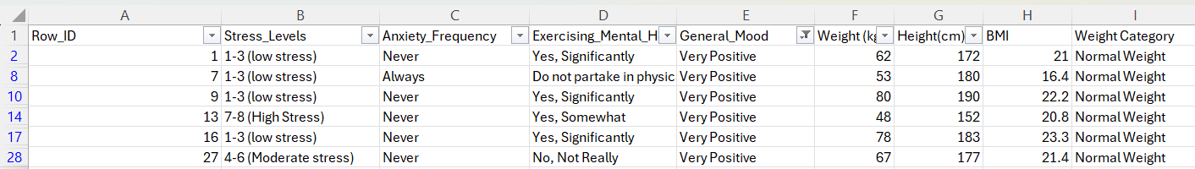
Figure 1 – Physical Activity vs Mood.
Impact of Physical Activity on Mental Health
Physical activity affects mental health, analysis found 7 out of 30 participant’s reported exercising significantly helped their mental health. This indicates that a portion of participants recognise the mental health benefits of regular physical activity.
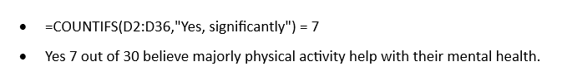
Figure 2 - Count Function
Mood Status Among Non-Exercisers
The analysis of participants reported not participating in physical activity reveals that 1 out of 5 non-exercisers (“)%) reported being in a positive mood. This contrast sharply with the higher rates of positive mood among physically active participants, suggesting that lack of physical activity may associated with less favourable mood states.
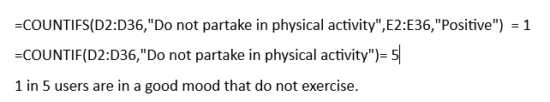
Figure 3 - Mood Status COUNT Calculation

Sedentary Behaviour by Age Group
The second dataset represents distinct patterns in sitting behaviour across age groups; the data reveals that younger individuals more frequent breaks from sitting compared to older age groups. This pattern particularly pronounced among students, who demonstrate more regular break-taking behaviour than other occupational groups. The table analysis highlights the relationship between age and average sitting time, with older age groups having less sitting time, due to a greater awareness of health risk associated with prolonged stillness among older adults.
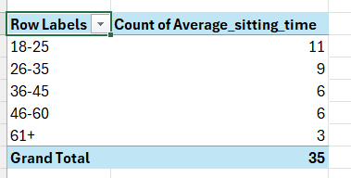
Figure 4 - Pivot Table
Extended Sitting Patterns
The analysis found patterns in extended sitting time across multiple demographic groups, notably 5 participants reported sitting for 10 or more hours while taking only one break throughout the day. These participants have various age groups, indicating extended sedentary behaviour is not limited to specific age demographics. Among desk job employees, a particularly high proportion reported sitting for more than 10 hours daily, indicating occupation as a significant risk factor for prolonged sedentary behaviour.
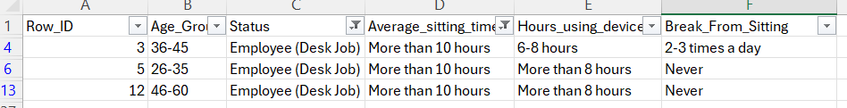
Figure 5 - Extended Sitting Patterns
Combined Risk Factors
A targeted analysis including participants from multiple risk factors, sitting for more than 8 hours, using devices for more than 6 hours and never taking breaks. This risk profile was found among desk job employees only suggesting environment plays a part in collective health risk.
Figure 6 - Risk Measures

Sleep Quality and Exercise Relationship
Analysis of the third dataset demonstrated a strong association between exercise frequency and sleep quality. All participants reported how not exercising rated their quality of sleep poorly, establishing a clear link between physical inactivity and sleep disturbances. Conversely, those who exercised daily predominantly rated their sleep quality as excellent and reported consistently feeling rested upon waking up. Many participants who exercised 5 or more days per week, 50% reported always feeling rested suggest that regular exercising contributes to improved sleep quality.
Figure 7 - Sleep Quality
Sleep Duration and Quality
The analysis identified a relationship between sleep duration and perceived sleep quality, participants who reported sleeping more than 8 hours consistently rated their sleep quality as excellent, regardless of how long it takes to fall asleep. This suggest that total sleep duration may be more significant in perceived sleep quality than sleep onset delay.
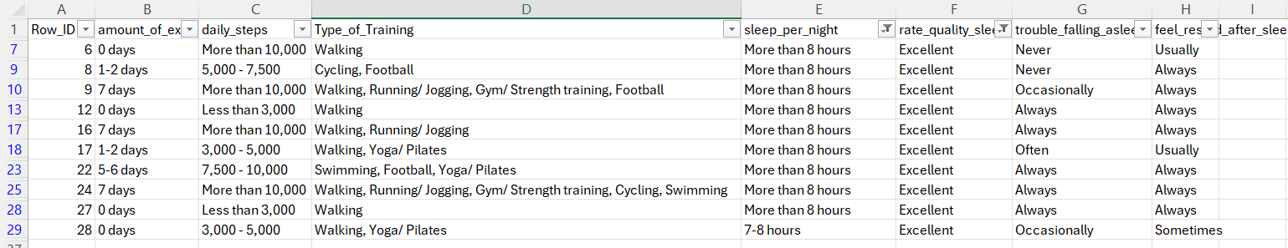
Figure 8 - Sleep Duration
Exercise Frequency and Sleep Quality
Pivot table analysis demonstrates a clear positive correlation between exercise frequency and sleep quality ratings. Participants exercising 5 or more days per week consistently reported higher sleep quality ratings compared to those exercising less frequently or not at all. However, the relationship between daily sleep count and feeling rested shows a variety, with some participants reporting feeling similarly rested regardless of their daily step count. This suggest that structured exercise may have a more consistent impact on sleep quality than overall daily movement.
Figure 9 - Frequency.
These Excel analysis findings establish fundamental relationships between sedentary behaviour physical activity and health outcomes across different demographic groups, providing a foundation for a detailed analysis using SQL.
4.2 SQL Analysis Findings
SQL queries allow for an insight to be discovered between sedentary behaviour, physical activity, and health results through cross analysis.
Stress Levels by Age Group and Sitting Time: This query highlights stress levels across age to which the sitting durations revealed that stress levels can be high regardless of age range or sitting behaviour. Despite that, 18-25 age group reported lowest average stress levels, potentially due to having fewer responsibilities compared to older age groups. This implies sedentary behaviour can contribute to stress, other life variables affect overall stress levels.
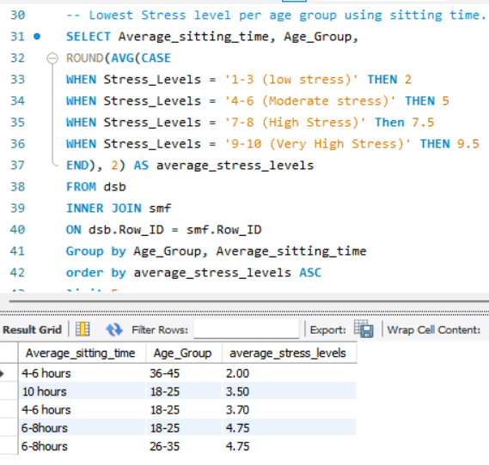
Figure 10 - Lowest Stress Levels
Device Usage and Sleep Quality: The relationship between using smart devices and sleep quality reveals actionable insights. Individuals limiting their screen time to less than 2 hours daily reported an excellent sleep quality. Whilst device usage of durations with fair sleep quality indicates that minimising screen time helps optimise sleep quality.
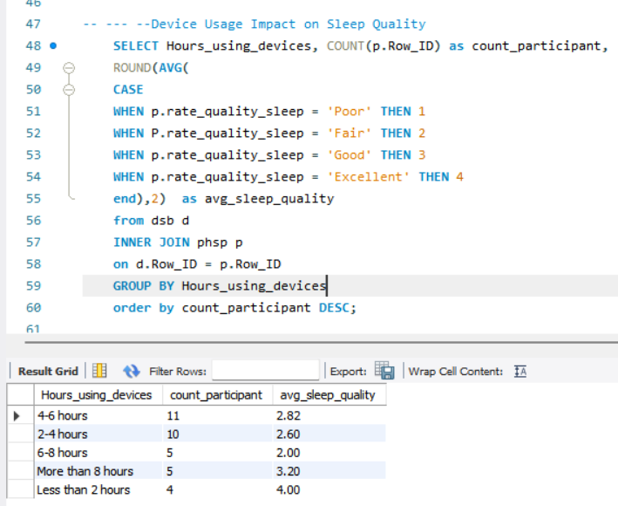
Figure 11 - Device Usage Impact
Break Frequency and Anxiety Levels: SQL queries examine the relationship between break frequency during sedentary periods and anxiety levels reveal a patter that those how 3 or more breaks from sitting down reported to rarely be anxious. Whilst those never took breaks reported higher anxious rates, these findings suggest that interrupting sedentary time can protect factor against anxiety development.
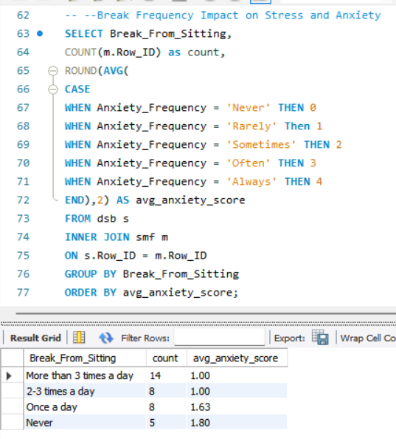
Figure 12 - Break Frequency and Anxiety Levels
Exercise Frequency and Sleep Disturbances: The analysis highlights the correlation between exercising and sleep quality, individuals who reported no exercise were significantly more likely to experience troubled sleep, whilst those who reported did trained for at least 1-2 days per week reported fewer sleep disturbances. This illustrates that levels of physical activity can yield sleep benefits with positive effects .
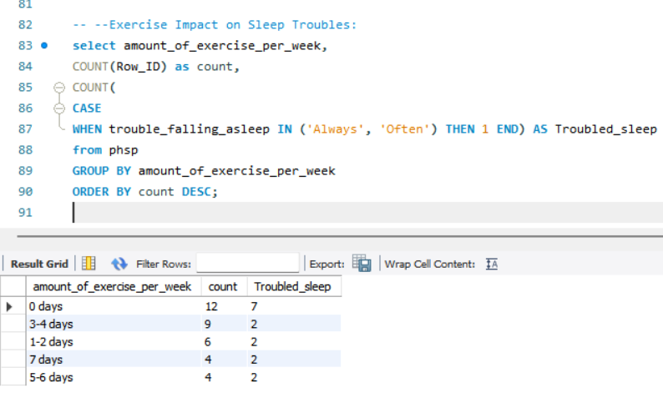
Figure 13 - Impact on Sleep Troubles

Daily Steps and Mood States: SQL analysis examining the relationship between daily step counts and mood states found that individuals with minimal steps were most likely to report negative mood states. Conversely, participants with higher step counts consistently reported more positive moods. This finding suggests that increasing daily movement can positively improve psychological wellbeing.
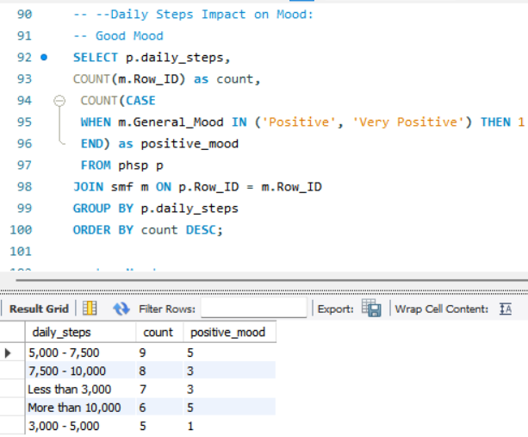
Figure 14 - Steps Impact
Age Group and Sedentary Behaviour Patterns: The analysis reveals interesting patterns in sedentary behaviour across age groups. 1 out of 3 aged over 61 reported elevated levels of sedentary behaviour, whilst age 18-25 displayed the lowest level of sedentary behaviour. This suggest that older adults be more health-conscious regarding sitting time, a significant may be particularly vulnerable to extended sedentary behaviour.
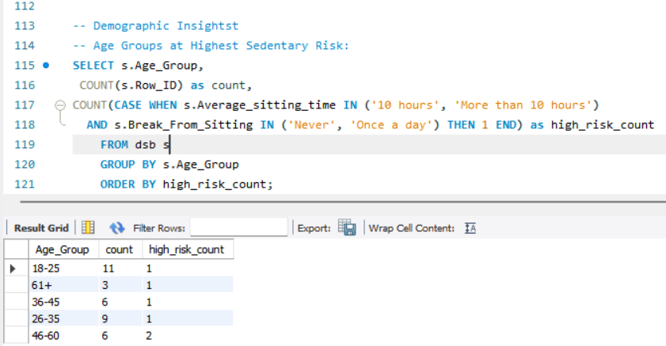
Figure 15 - Age Group and Sedentary Behaviour Patterns
Occupation and BMI Relationship: SQL queries examining the relationship between occupation and BMI reveals that desk job employees had the highest average BMI and were the most likely to fall in the overweight category. Whilst students had the lowest average BMI and highest set within the “normal weight” range. This highlights occupations as a significant factor influencing body composition, potentially through its impact on daily activity levels and sedentary behaviour.
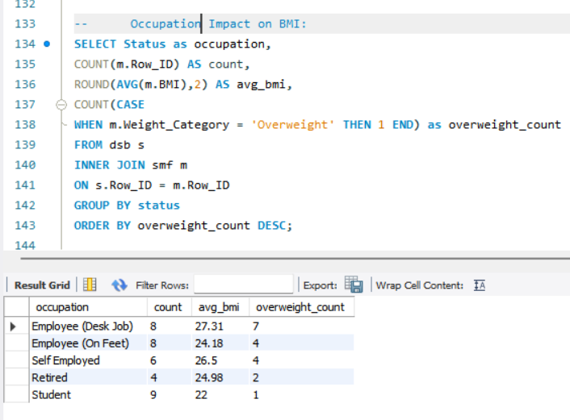
Figure 16 - Occupation Impact on BMI
Mental Health, Age Group and Exercise Among Students: An analysis of students revealed an unexpected finding, mental stress levels depicted minimal alignment with exercise frequency in this demographic. Students reporting daily exercise and those reporting not exercising both fell into the low stress category, highlight there are factors beyond physical activity may strongly influence mental health outcomes.
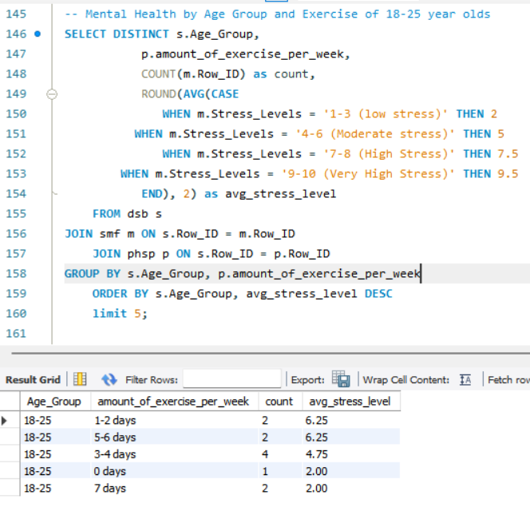
Figure 17 - Mental Health by Age Group
Sleep Quality, Exercise and BMI Relationships: SQL queries examining the relationship between sleep quality, exercise frequency and BMI revealed that participants exercising 4 days per week who maintained a normal weight consistently reported excellent sleep quality. Interestingly, overweight participants who exercise 4 days per week also reported good sleep quality, potentially indicating a weight management journey with positive sleep outcomes. The analysis discovered only one normal-weight participant who did not exercise and reported poor sleep quality, highlighting the rarity of positive sleep outcomes in the absence of physical activity.
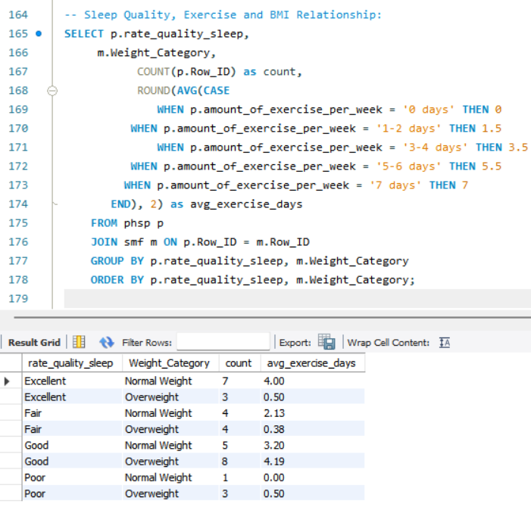
Figure 18 - Sleep Quality, Exercise
These findings provide an understanding into the relationship of sedentary behaviour, physical activity, and health measurements across demographics groups. The analysis reveals both expected patterns and surprising relationship that contribute to a more nuanced understanding of how lifestyle factors interact to influence wellbeing.

4.3 Tableau Visualization Findings
The visualizations provided a presentation of relationships found in Excel and SQL analysis, offering further insights through multi-dimensional displays.
Sitting time by Occupations: Students sit for 4-6 hours daily, which is a typical workload, whilst employees working on their feed reported sitting up for 10 hours during downtime, highlighting their fatigue after prolonged standing periods. This indicates occupations and sedentary behaviour have a significant pattern.
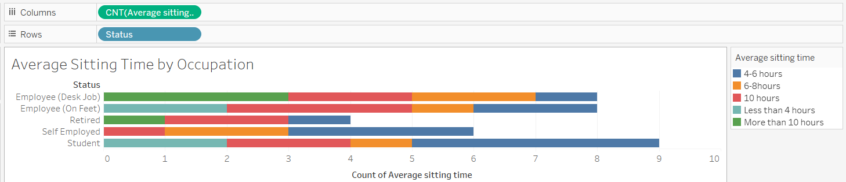
Figure 19 - Clustered Chart
Sitting Time and Device Usage Relationship: 4-6 hours is the daily participant usage; this pie chart represents the common time slots for users to use.
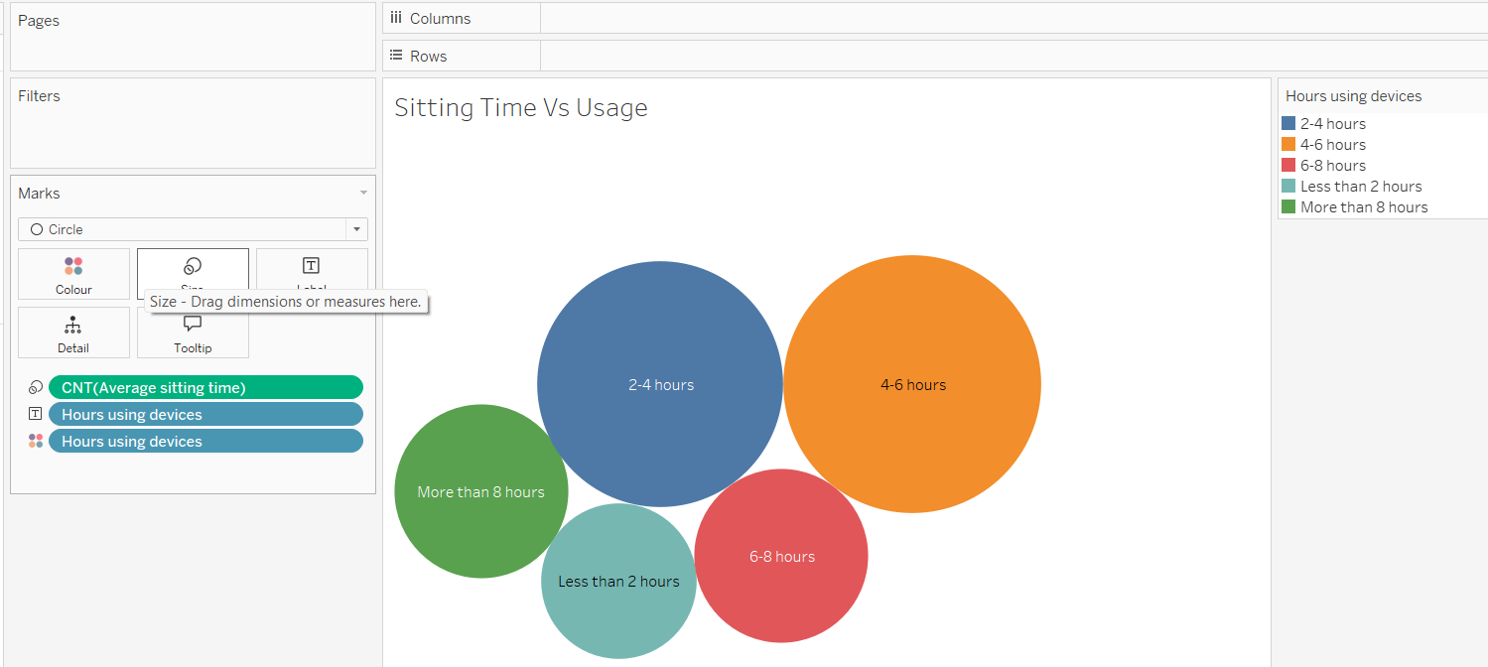
Figure 20 - Pie Chart
Exercise impact on sleep quality: The bar chart presents all four viable options, to which exercising 3-4 consistently reports good sleep quality, whilst those the only poor sleep quality individuals are those who rarely exercise. This highlights the consistency of poor-quality sleep amongst non-exercisers strengthening the evidence for a causal relationship between physical activity and sleep outcomes.
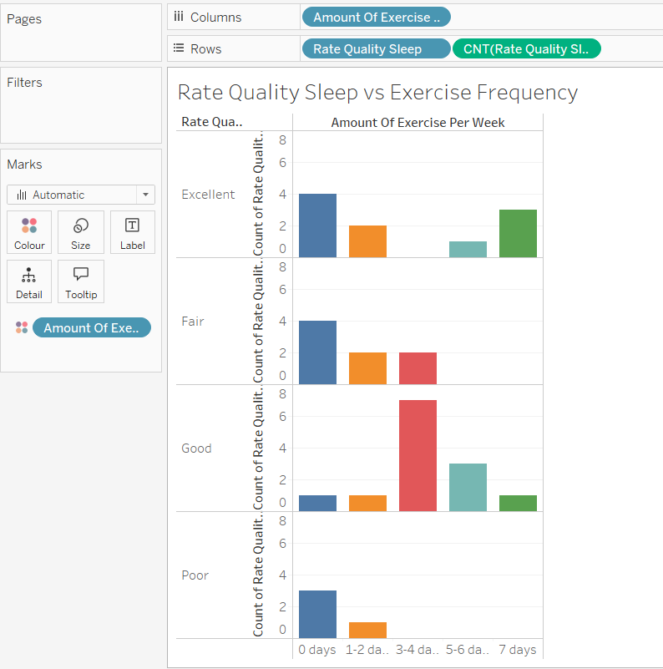
Figure 21 - 4 Bar Charts
Daily Steps and Sleep Patterns: The visualisation highlights that the 7.5k to 10k steps daily reported to a good sleep quality and those how exceeded 10k an excellent sleep. The bar chart provides an understanding of the relationship between daily movement and sleep quality.
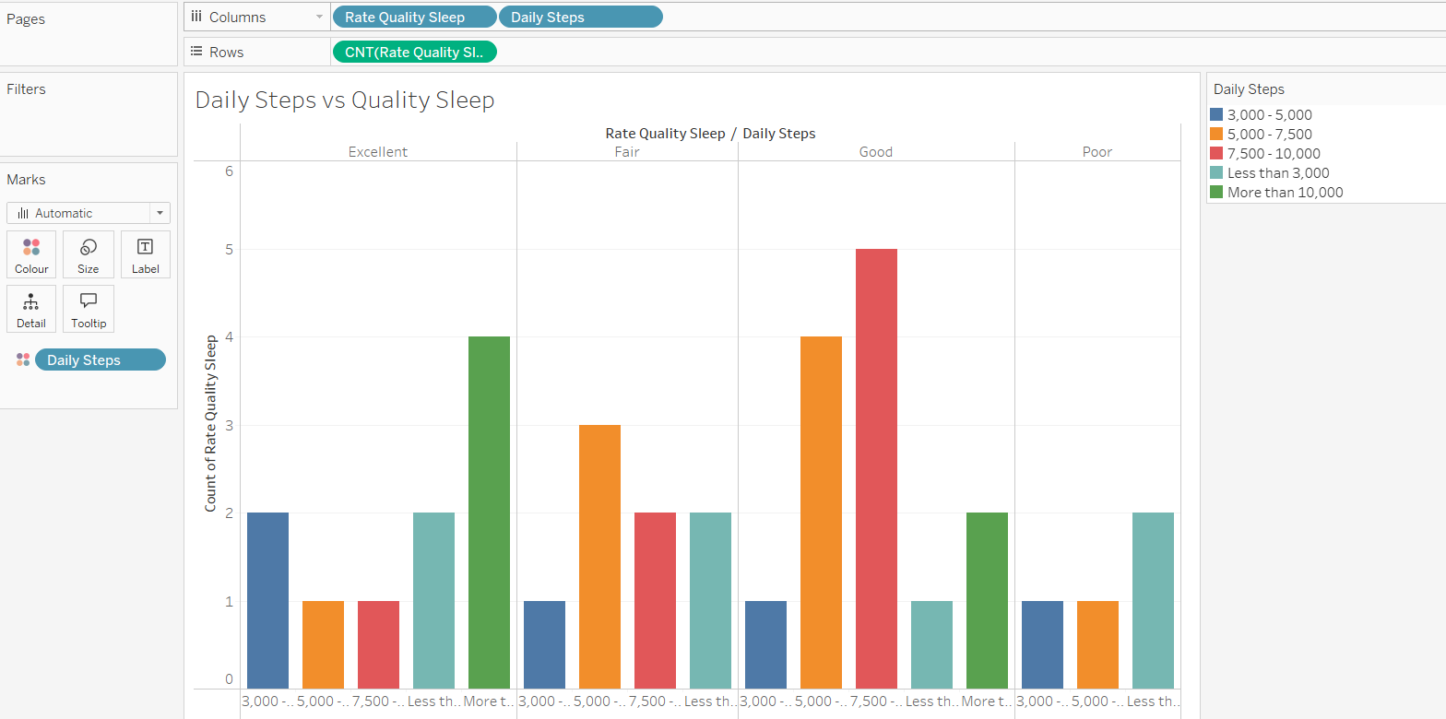
Figure 22 - Bar Chart
The visualisation enhanced the understanding of relationship between health, exercise and sitting behaviour.

Chapter 5: Discussion and Recommendations
5.1 Interpretation of Key Findings
The findings of this research highlight critical relationships between sedentary behaviour, physical activity, and health outcomes that warrant detailed interpretation in the context of lifestyle patterns.
The Physical Activity-Mood Connection
There is a positive relation with exercising with 20% believe it significantly helps with their mental health. The remaining individuals without have other motivating factors to help them exercise, whilst only 20% of non-exercisers reported a positive mood. These strengths the interpretation that physical activity is a factor in maintain psychological wellbeing.
Sedentary Behaviour Across Demographics
The relationships between age and sitting time is an interesting finding, contradicting the common assumptions that sedentary behaviour increases with age. This pattens reflects health consciousness among older adults who have experienced or witnessed age-related health problems, with the aim to deliberately move patterns. However, the adults over 61 with high sedentary behaviour highlights the unfairness of generalisations across age groups. This represents individuals with limitations or conditions that restrict movement, suggesting the need for interventions for vulnerable demographic groups.
The impact sedentary behaviour has on occupations is clear, with desk job employees highest average BMI and were most likely to fall into being overweight. However, to their defence they are the more likely to take breaks than self-employed individuals. Student’s flexibility in daily scheduling potentially allows to minimise sedentary behaviour and more exposure to health education.
Sleep Quality
The relationship between exercise frequency and sleep quality is strongly supports physical activity improves sleep. The findings that even modest exercise frequency (1-2 weekly) can improve sleep compared to no exercise at all. Under 2 device screen time reflect the biological impact of blue light on the mind and the psychological effects of digital devices before sleep.
Demographic Requirements
There are behavioural patterns in health relationship across demographic groups tailor interventions approaches. Students and desk role employees demonstrate different break-taking behaviours suggests that interventions promoting breaks would require different implementations methods across groups. The observation that stress across students shows limited correlation with exercise frequency suggests that exercising for this demographic needs to be complemented with stress management approaches specific to academic contexts.
Adults over 61 with high sedentary behaviour to needs for specialised intervention for older adults with mobility limitations. Rather than typical exercising forms, interventions for groups might focus on seated movement opportunities and gradual mobility enhancement.
Technology
The relationship between device usage and various health outcomes presents challenges and opportunities for intervention design. Whilst extended device usage correlates with negative outcomes, technology itself offers powerful tools for behaviour change. The finding participants takes breaks from sitting consistently limited their device usage suggests potential for interventions that integrate break prompts into digital interfaces. Similarly, the relationship between step counts and mood states indicates potential for step-tracking applications to incorporate mood monitoring, highlights the psychological positives of increased movements.
Workplace
The identification of occupations as a factor influencing sedentary behaviour highlights the importance of workplace-based interventions. Desk job staff have the highest average BMI despite taking more breaks than self-employed individuals suggests that breaks may be insufficient in duration or quality to offset extended sitting periods. This implications for workplace policies suggests the need for more substantial activity breaks rather than brief interruptions to sitting time.
The students demonstrated healthier patterns than desk job employees despite similar environmental constraints suggests potential for educational institutions to serve models for workplace policy development. Identifying the specific factors that facilitate healthier behaviour among students could inform workplace redesign to promote similar patterns among employees. These implications collectively highlight the need for multifaced, context-specific health interventions that address the complex relationships between sedentary behaviour, exercising and health outcomes in research.
5.3 Recommendations for Different Demographics
Based on the research findings, the demographics recommendations are proposed to address sedentary behaviour and improve associated health outcomes.
Young Adults (18-25)
Movement: The education sector should integrate movement opportunities throughout campus environments, with the finding that this age group already demonstrates more frequent break-taking behaviour than older demographics. Recommendations include creating active learning spaces that allow movement during study sessions and incorporating standing desks in library and study areas.
Wellness Program: Address findings that device usage tends to cluster with sitting time; institutions should implement a wellness program to target young adults. These should include screen time awareness campaigns highlights the sleep benefits of limiting device usage to under 2 hours daily and providing tools for screen time.
Stress-Movement Education: Given that finding that his age group reports the lowest average stress levels despite significant academic pressures, educational programs should connect movement practices to stress management. This includes promoting movement practices during high-stress academic periods and creating guided movement session specifically designed for an exam preparation period.
Working Adults (26-60)
Occupation-specific movement: Findings that occupation significantly influences sedentary patterns; employers should develop role-specific movement protocols. For desk job employees, this includes implementing mandatory movement breaks (minimum of 3, based on the anxiety reduction threshold identified) and providing alternative workspace options such as standing desks or walking meeting areas.
Break Quality Enhancement: Addressing the finding that desk job employees take breaks but still demonstrate high BMI, employers should focus on break quality rather than frequency alone. Recommendations include structured movement breaks of at least 10 minutes rather than constant interruptions and providing a guide to different movement options (stretch routines, walking paths) that maximise physical benefit within time constraint.
Commute Transformation: Finding that approximately 10,000 daily steps correlate with sleep quality, employers should implement programs that transform commuting into active time.
Support Network: Addressing the finding that self-employed individuals demonstrate less frequent break-taking behaviour, professional organization serving this demographic should develop movement accountability networks. These include virtual co-working session with scheduled movement breaks and professional development offering that integrate movement practices.
Older Adults(61+)
Movement programs: Based on identifying of a subset of older adults with high sedentary behaviour, community organizations should implement a movement program for mobility levels. This includes social movement opportunities to address both physical and social wellbeing.
Technology-Assisted Movement: Addressing that findings device usage remains significant across age groups, senior-focused organisations should develop technology training that incorporates movement prompts. This includes educating older adults about activity application reminders and providing that integrates movement prompts ( video games requiring physical movement.
Sleep-Movement Connection education: Given the strong relationship between exercise frequency and sleep quality, healthcare providers serving older adults should explicitly connect these factors in patient education. This includes specific movement for patients reporting sleep quality and monitoring both exercise and sleep outcomes during regular health outcomes.
Cross-Demographic Recommendations
Family-Based Movement Strategies: Addressing the behaviour patterns across age groups, community organizations should implement family-based programs that leverage generational influence. These include family movement challenges where different generations motivate each other, and community spaces designed to accommodate activity for multiple age groups.
Movement Messaging: Based on the finding that mood positivity correlates with physical activity across demographic, public health should emphasise the psychological benefits of movement rather than focusing solely on long-term physical health outcomes. This increase motivation across age groups by highlighting benefits experienced within a single day rather than over extended periods.
Comprehensive Sleep Improvement: Given the findings connecting device usage, physical activity, and sleep quality across demographics, healthcare providers should implement comprehensive sleep assessment and intervention approaches. These includes evaluating all three factors during sleep consultation and providing integrated recommendations that address movement patterns, screen time, and traditional sleep hygiene simultaneously.
These specific recommendations provide actionable strategies for addressing sedentary behaviour and improve associated health outcomes across population group, based directly on the research findings.

5.4 Strategies for Reducing Sedentary Behaviour
Drawing on the research findings, the following evidence-based strategies are recommended for reducing sedentary behaviour across different contexts:
Environmental Change
Design: Physical environments should redesign to naturally interrupt sedentary behaviour. Based on the findings that break frequency significantly impacts anxiety levels, workplaces and educational institutions should implement resource placements (printers, water stations, restrooms) requiring regular movement from primary sitting locations. Home environment recommendations include separating commonly used items (remote controls, chargers) from seating areas to necessitate regular standing.
Movement Prompts: Addressing the findings of participants who take breaks consistently demonstrated better health outcomes, all environments should include visual cues promoting movement. These include floor markings indicating walking paths, signage suggesting movement breaks at spaces (elevators, stairwells), and environmental design elements that encourage standing.
Technology Placement Strategy: The relationship between sedentary behaviour and device usage, strategic technology placement can reduce extended sitting periods. Recommendations include positioning screens at standing height in shared spaces, creating “standing only” technological zone and designing physical separation between device charging stations and seating areas to necessitate movement during device use.
Technological Interventions
Rest systems: Building on the finding that 3 or more breaks from sitting were associated with reduced anxiety, technology systems should implement smart break prompts based on individual sitting patterns. These AI-enhanced chair sensors that detect extended sitting and prompt movement, wearable devices programmed with personalised break algorithms, and smart workplace systems that restrict screen access after predetermined sitting periods.
Integrating Platforms: Addressing the finding that physical activity benefits emerge even at modest levels, digital platforms should integrate activity opportunities into otherwise sedentary tasks. These include meeting software with built-in movement breaks, educational platforms that release content in segments requiring physical interaction between segments and entertainment systems that pause content delivery at intervals for suggested movements.
Social networks: Building on findings regarding the relationship between movement and psychological wellbeing, technology platforms should facilitate social connections around movement. These include virtual movement buddies that synchronize break times across remote workers, family activity tracking systems that celebrate collective movement achievements, and social media integrations that prioritize movement-based content sharing.
Behavioural Systems
Reward Systems: Addressing the findings that break frequency impacts health outcomes independently of total sitting time, organisations should implement reward system for consistent break-taking behaviour. These include point-based systems awarding small benefits (preferred parking, coffee credits) for document breaks.
Transportation incentives: Given the findings that 10,000 daily steps correlate with sleep quality, organisations should offer incentives for active transporting. These include financial incentives for bicycle commuting, preferred parking allocation for carpools that park at walking distance from entrances, and public transportation options that increase walking compared to direct car commuting.
Sleep-Movement Connection Programs: Building on the strong relationships between exercise frequency and sleep quality, wellness programs should create connections between factors through incentive design. These include sleep quality improvement challenges with movement components, sleep tracking technologies that provide movement suggestions based on sleep patterns, and reward systems that recognise both sleep hygiene and physical activity improvements simultaneously.
Policy and Cultural Interventions
Meeting transformation policies: Address the impact an occupation can have on sedentary behaviour; organisations should implement policies transforming traditionally sedentary meeting. These include mandatory standing components for meetings exceeding 30 minutes, walking meeting protocols for discussions involving fewer than four people, and meeting scheduling systems that automatically incorporate movements breaks for extended sessions.
Active Work Definition Expansion: Building on findings regarding occupation-specific sedentary patterns, organisations should expand definitions of active work through policy changes. These include formally recognising movements as productive work time, incorporating physical activity goals intro performance metrics when appropriate, and create role descriptions that explicitly include movement responsibilities.
Sedentary Reduction Leadership: Given the finding that sedentary behaviour patterns vary significantly across demographic, organizations should implement leadership approaches that address these variations. These include creating movement champions represents different demographic groups establishing leadership role modelling of break-taking behaviour and incorporating sedentary reduction success into leadership evaluation metrics.
These strategies provide comprehensive approaches to reducing sedentary behaviour across different contexts, addressing the numerous factors identified in the research as influencing sedentary behaviour patterns and their associated health outcomes.

Chapter 6: Conclusion
6.1 Summary of Work Undertaken
This project investigates relationships between sedentary behaviour, physical activity patterns, and other health factors across demographic groups. The aim is to identify specific patterns that could inform targeted interventions to improve overall wellbeing, conveying public health concerns of increasing sedentary behaviour. The research used an analytical approach combining Excel, SQL, and Tableau to analyse, visualize patterns within datasets. This method allows to examine relationships between variables and identify meaningful patterns across demographic groups. The Excel analysis fundamentals between sedentary behaviour, physical activity, and health outcomes, revealing strong correlations between mood and physical activity levels, patterns of extended sitting across multiple demographic groups, and relationships between exercise frequency and sleep quality. Thes findings provided direction for detailed analysis using SQL and Tableau.
SQL allowed to find deeper relationships through complex queries and cross-dataset analysis to reveal patterns. The analytical approach uncovered significant insights regarding stress levels across age group and sitting durations, relationships between device usage and sleep quality, associations between anxiety levels and break frequency, with a connection found between daily steps and mood states. SQL methodology was valuable in identifying effects, such as finding that taking 3 or more breaks from sitting was associated with experiencing anxiety “rarely”.
Tableau visualisations enhanced understanding by powerful visual representation of the patterns and relationships identified. These revealed additional insights through interactive and multi-dimensional displays, highlighting patterns in sedentary behaviour across demographics, illustrating the relationship between sitting time and device usage, with also highlighting the relationship between BMI, exercise frequency, and psychological wellbeing. This approach was effective in communicating complex relationships in an accessible manner.
The analysis findings across analytical approaches, provides evidence based through results, this establishes connections between physical and activity and psychological well-being, exercise frequency and sleep quality, occupation and sedentary behaviour patterns, age-related variations in sitting time, and device usage impacts on health outcomes.
These findings developed detailed interpretations of key results, explored implications for health interventions, formulated demographic-specific recommendation, and proposed evidence-based strategies for reducing sedentary behaviour. The conclusion directly addresses the research aims by providing actionable insights that can inform targeted intervention to improve health outcomes across diverse populations.
The work undertaken represents a contribution to understanding how sedentary behaviour impacts overall wellbeing across diverse groups, findings patterns to guide the development of interventions to address public health concern.
6.2 Limitations
The research has several limitations that should be considered when dealing with findings and considering their applications.

Methodological Limitations
The data collection provides a relationship between variables at a single point in time, limiting the ability to establish causal relationships indefinitely. With strong associations between physical activity and various health outcomes were identified, but there is a lack of longitudinal data.
The reported nature of data collection introduces potential reporting biases, particularly regarding sensitive metrics like BMI, device usage duration, and psychological states. Participants may underreport behaviours seen as unhealth (extended sitting, limited physical activity) and overreport positive traits (exercise duration), which increases the identified relationships. The absence of objective measurement tools for sedentary behaviour (posture monitors) and health results (sleep assessment) further limits measurement precision.
The size is adequate for primary analyses but is limiting when examining specific demographic subgroups. This is evident when analysing older adults and self-employed individuals, where smaller representation may have affected the robustness of findings for these groups. This convenience sampling approach may introduce bias, leading to overrepresentation of participants with pre-existing interest in health behaviours and underrepresentation with those with limited health awareness.
Contextual Limitations
The research was conducted during a period of significant transition in work and educational patterns, with many organisation implementing hybrid models following global disruptions to traditional arrangements as the dataset since the pandemic. This context creates behavioural limitations to stable periods. Sedentary behaviour can influence temporary adaptations rather than representing established patterns.
Cultural context wasn’t specified, limiting understanding of how cultural factors might influence relationship between sedentary behaviour and health outcomes. Diverse cultural attitudes toward movement, leisure and work-life balance impact these relationships in ways not captured by the current analysis.
The categorisation used in reseach (desk job employees, self-employed, students, employees working on their feet) provides useful but broad grouping that obscure important variations within categories. For instance, desk job employees in different industries may experience different workplace cultures regarding movement opportunities, and self-employed participants can span a variety of work arrangements with varying sedentary requirements.
Analytical Limitations
The research focused on primarily on direct relationships between variables without incorporating more complex statistical modelling that could account for factors and interaction effects. Multi-method approach strengthens confidence in identified relationships; more sophisticated statistical approaches could provide greater insights into how multiple factors simultaneously influence outcomes.
Device usage focuses primarily on duration rather than the nature of activity being performed, potentially overlooking important distinctions between diverse types of the activity being performed, overlooking important unique variables between types of screen time. Passive entertainment consumption, active social engagement, and work-related device usage have different relationships with health outcomes that were not captured in the current analysis.
6.3 Further Work
There is further work proposed, building on the findings and addressing the limitations of the current research.
Improvements
Research should implement further study design to establish relationships over a minimum of 12 months, this would be able to identify sequences in outcomes, clarifying whether physical activity precedes improved psychological wellbeing or whether positive psychological states enhance movement motivation. This approach would capture seasonal variations in behavioural patterns that significantly impact outcomes.
Integrating objective measurement technologies would enhance data quality in future studies. Track watches could provide monitoring of movement patterns, smart chair could track precise sitting durations and break frequencies, and sleep monitoring devices could assess sleep patterns. These technologies reduce reporting biases and enable analysis of behaviour patterns, potentially revealing effects not detectable through self-reporting.
Expanding sample size and implementation of sample can address limitations in demographic representation. With a focus should be place on recruiting adequate representation of older adults, diverse occupational categories, and individual with varying baseline health status. This expanded approach would enable more analysis of demographic-specific patterns and potentially identify vulnerable subgroups requiring targeted intervention.
Expansion
Further work should include how environmental contexts influence sedentary behaviour patterns and their health implications. Comparative studies across different work styles can provide insight into how physical environment characteristics movement opportunities and constraints. Similarly, comparing institutions with different space configurations could inform optimal design for reducing student sedentary time.
Research examining how cultural factors influence relationships between sedentary behaviour and health outcomes as different attitude to work can modify the relationship and inform sensitive intervention approaches. This work is valuable for multinational organisations implementing global wellbeing initiatives.
Examination of occupational subcategories would provide a detailed understanding of work-related patterns. Research between several types of deskwork (creative, technical), various self-employment arrangements (client-faced, home-based), and different student categories (undergraduate, postgraduate) can identify occupation risk factors and intervention opportunities that is not apparent in broader categorisations.
Analytical Advancements
Statistical modelling techniques enhances understanding of complex relationships between multiple variables. This style provides more understanding of how multiple factors simultaneously influence well-being of participants.

Detailed response analyses refine understanding of thresholds identified in current research. Future work should systematically vary (exercise duration, step count) to establish targets than minimum effective thresholds. This precision enhances intervention design by providing evidence-based targets tailored to specific health outcomes.
Qualitative research components would work well with quantitative findings by exploring subjective experiences of sedentary behaviour and movement. In-depth interviews with individuals from different demographics groups could uncover motivational factors, perceived barriers, and cultural influences not captured in quantitative data. This mixed-methods approach would enrich understanding of behaviour patterns and inform effective intervention messaging.
Intervention Development and Testing
Future work should develop and test interventions targeting specific thresholds identified in the research. A trial randomised examining interventions promoting 3+ daily breaks, approximately 10,000 steps and device usage limitations would establish whether modifying these specific parameters yields predicted health benefits. These trails should include adequate follow-up periods to assess sustainability of behaviour changes and persistence of health benefits.
Development and validation of demographic-specific interventions represent a critical direction for future work. Evaluating the recommendations provided for different age groups and occupational categories would determine their effectiveness in real-word context and refine based on implementation experiences. This approach would address significant variations in behaviour patterns and health relationships identified across demographic groups.
Integration of technological solutions into intervention design presents opportunities for future research. Development and testing of smart brake system, activity integration platforms, and social movement networks would leverage technological capabilities to address sedentary behaviour while accommodating contemporary digital lifestyles. Then, evaluating these technologies interventions across different demographic groups would provide insights into their differential effectiveness and acceptance.
Heading towards this style for further development would build upon the established foundation addressing its limitations whilst expanding its application to enhance understanding of sedentary behaviour patterns and develop effective interventions to improve associated health outcomes across diverse populations.

7. References
Park, J.H., Moon, J.H., Kim, H.J., Kong, M.H. and Oh, Y.H., 2020. Sedentary lifestyle: Overview of updated evidence of potential health risks. Korean Journal of Family Medicine, 41(6), pp.365–373. Available at: https://www.ncbi.nlm.nih.gov/pmc/articles/PMC7700832/ [Accessed 17 Apr. 2025].
Salman, D., Farooqi, M., McGregor, A., & Majeed, A. (2019). Time spent being sedentary: an emerging risk factor for poor health. British Journal of General Practice, 69(683), 278-279. https://doi.org/10.3399/bjgp19X703781. [Accessed 21 March 2025].
Lavie, C.J., Ozemek, C., Carbone, S., Katzmarzyk, P.T. and Blair, S.N., 2019. Sedentary behavior, exercise, and cardiovascular health. Circulation Research, 124(5). Available at: https://doi.org/10.1161/CIRCRESAHA.118.312669. [Accessed 22 March 2025]
Wang, F. and Boros, S., 2019. The effect of physical activity on sleep quality: a systematic review. European Journal of Physiotherapy, 21(1), pp.11–18. Available at: https://www.tandfonline.com/doi/full/10.1080/21679169.2019.1623314 [Accessed 17 Apr. 2025].
Lopes, T.R., Pereira, H.M., Bittencourt, L.R.A. & Silva, B.M., 2022. How much does sleep deprivation impair endurance performance? A systematic review and meta-analysis. European Journal of Sport Science, 22(9), pp.1279-1292. Available at: https://doi.org/10.1080/17461391.2022.2155583 [Accessed 17 Apr. 2025].
Papatriantafyllou, E., Efthymiou, D., Zoumbaneas, E., Popescu, C.A. & Vassilopoulou, E., 2022. Sleep Deprivation: Effects on Weight Loss and Weight Loss Maintenance. Nutrients, 14(8), p.1549. Available at: https://doi.org/10.3390/nu14081549 [Accessed 17 April 2025].
Fossati, C., Torre, G., Vasta, S., Giombini, A., Quaranta, F., Papalia, R. and Pigozzi, F., 2021. Physical exercise and mental health: The routes of a reciprocal relation. International Journal of Environmental Research and Public Health, 18(23), p.12364. https://doi.org/10.3390/ijerph182312364 [Accessed 17 Apr. 2025].
Merino, M., Tornero-Aguilera, J.F., Rubio-Zarapuz, A., Villanueva-Tobaldo, C.V., Martín-Rodríguez, A. and Clemente-Suárez, V.J., 2024. Body perceptions and psychological well-being: A review of the impact of social media and physical measurements on self-esteem and mental health with a focus on body image satisfaction and its relationship with cultural and gender factors. Healthcare, 12(14), p.1396. https://doi.org/10.3390/healthcare12141396 [Accessed 17 Apr. 2025].

World Health Organisation (2024) 'Nearly 1.8 billion adults at risk of disease from not doing enough physical activity', WHO News, 26 June. Available at: https://www.who.int/news/item/26-06-2024-nearly-1-8-billion-adults-at-risk-of-disease-from-not-doing-enough-physical-activity (Accessed: 31 May 2025).
Yang, Z., Hotterbeex, P., Marent, P.-J., Cerin, E., Thomis, M., & van Uffelen, J. (2024). Physical activity, sedentary behaviour, and cognitive function among older adults: A bibliometric analysis from 2004 to 2024. Ageing Research Reviews, 97, 102283. Available at: https://doi.org/10.1016/j.arr.2024.102283 [Accessed 19 Sept. 2025].
Stockwell, S., Trott, M., Tully, M., Shin, J., Barnett, Y., Butler, L., McDermott, D., Schuch, F. & Smith, L., 2021. Changes in physical activity and sedentary behaviours from before to during the COVID-19 pandemic lockdown: a systematic review. BMJ Open Sport & Exercise Medicine, 7(1), e000960. Available at: https://bmjopensem.bmj.com/content/7/1/e000960 [Accessed 19 Sept. 2025].
Kolu, P., Kari, J.T., Raitanen, J., Sievänen, H., Tokola, K., Havas, E., Pehkonen, J., Tammelin, T.H., Pahkala, K., Hutri-Kähönen, N., Raitakari, O.T. & Vasankari, T., 2022. Economic burden of low physical activity and high sedentary behaviour in Finland. Journal of Epidemiology & Community Health, 76(7), pp.677–683. Available at: https://jech.bmj.com/content/76/7/677 [Accessed 19 Sept. 2025].
Koohsari, M.J., Yasunaga, A., McCormack, G.R., Shibata, A., Ishii, K., Liao, Y., Nagai, Y. & Oka, K., 2023. Sedentary behaviour and sleep quality. Scientific Reports, 13, Article number: 1180. Available at: https://doi.org/10.1038/s41598-023-27882-z [Accessed 19 Sept. 2025].
Alosaimi, N., Sherar, L.B., Griffiths, P. & Pearson, N., 2023. Clustering of diet, physical activity and sedentary behaviour and related physical and mental health outcomes: a systematic review. BMC Public Health, 23, Article number: 1572. Available at: https://doi.org/10.1186/s12889-023-16372-6 [Accessed 19 Sept. 2025].
Parés-Salomón, I., Señé-Mir, A.M., Martín-Bozas, F., Loef, B., Coffey, A., Dowd, K.P., Jabardo-Camprubí, G., Proper, K.I., Puig-Ribera, A. & Bort-Roig, J., 2024. Effectiveness of workplace interventions with digital elements to reduce sedentary behaviours in office employees: a systematic review and meta-analysis. International Journal of Behavioral Nutrition and Physical Activity, 21, Article no. 41. Available at: https://doi.org/10.1186/s12966-024-01595-6 [Accessed 19 Sept. 2025].

